BILL SPLITTER & TIP CALCULATOR
Project Report
CSE215 / Programming Language II
ECE / North South University
Submitted by:
Navid Shahriar khan – 2531416042
Afra Anan Aubonee – 2533224642
Subah Soria – 2533295042
Faculty: Dr. Shamim Al Mamun (SAM3)
Submission Date: 16th August, 2026

Table of Contents

- Introduction
- Project Overview
- Objectives
- Requirements and Use Cases
- OOP Concepts
- Testing and Results
- Limitations and Future Improvements
- Conclusion
- References
- Appendix A – Screenshots
- Appendix B – UML

1. Introduction
Splitting a restaurant bill among a group of friends can become complicated when everyone orders different items or shares some items with others. The situation becomes even more difficult when taxes, tips, and different cash contributions have to be considered. Manual calculations can easily lead to confusion or incorrect amounts, particularly when each person is responsible for a different portion of the total bill.
The Bill Splitter & Tip Calculator was developed as a Java desktop application to simplify this process. The project provides a structured way to represent friends, bill items, and their relationships while performing the necessary calculations to determine each person's financial responsibility. Rather than relying on manual calculations, the application organizes the information and produces consistent results through a graphical user interface.
The project was developed as an Object-Oriented Programming application, with its design centered around classes and objects that represent the real-world components of a shared bill. It also provides an opportunity to apply important Java and OOP concepts in a practical context, including encapsulation, abstraction, inheritance, polymorphism, interfaces, arrays, exception handling, and GUI development.
This report presents the problem addressed by the project, its objectives and requirements, the object-oriented design and implementation, the testing process and results, and the limitations and possible future improvements of the application.

1.1 Problem Statement
The main problem is that a single restaurant bill does not necessarily represent an equal expense for every member of a group. Each person may have an individual entree, several people may share an appetizer, and tax and tip increase the final amount beyond the original menu prices. In addition, the amount actually paid by each member may not match the amount they are responsible for. A manual process therefore requires repeated calculations for item allocation, tax, tip, overpayment, underpayment, and final settlement.

1.2 Project Purpose
The project was built to automate these calculations in one desktop application. Its purpose is to eliminate arithmetic mistakes, make the responsibility of each group member transparent, and demonstrate how an everyday problem can be modeled using object-oriented programming. Instead of treating the bill as one large calculation, the system represents friends and bill items as objects and gives each class a clear responsibility.

1.3 Report Overview
The following sections describe the project scope and features, objectives, requirements and use cases, OOP concepts and system design, implementation logic, testing and results, current limitations and future improvements, and the final conclusion. The appendices are reserved for screenshots and the final UML or selected code excerpts.

2. Project Overview
From the user's point of view, Bill Splitter & Tip Calculator is a guided desktop application for preparing and settling a group restaurant bill. The bill handler first creates the group and records each friend's cash contribution. Bill items can then be entered as individual entrees or shared appetizers. For shared items, the user selects exactly which friends are involved, so the cost is divided among the correct participants rather than across the whole group.
After the items are entered, the user selects a supported tip percentage and enters the tax percentage. The application calculates the subtotal, tax, tip, grand total, and each friend's responsibility. It then compares responsibility with cash contributed to identify overpayments and outstanding amounts. Finally, the settlement logic produces transactions that move money from members who still owe to members who have paid more than their responsibilities.

2.1 Users
The primary user is the bill handler, who operates the main GUI, enters the group and bill information, performs the final calculation, and generates settlement transactions. Group members are represented inside the system as Friend objects. They do not require separate accounts; their names, purchases or shared-item participation, cash contributions, responsibilities, and resulting balances are managed within the same session.

2.2 Scope
The project is limited to a local Java desktop application designed for splitting restaurant expenses among a small group of people. Its scope covers the calculation and organization of shared expenses, including the relationships between group members, bill items, taxes, tips, and final balances.
The current version does not include online accounts, cloud synchronization, database storage, online payment processing, or integration with external restaurant or banking services. It is also designed within the constraints of an introductory OOP course, so fixed-size arrays are used for storing group members and bill items rather than a database or dynamic collection framework.
The project focuses primarily on demonstrating object-oriented programming concepts through a practical bill-splitting problem rather than providing a full-scale commercial expense-management system.

2.3 Main Features
- Add group members and record the cash amount each person contributes.
- Add individual entrees and shared appetizers.
- Split shared item costs only among the selected participants.
- Apply a fixed item tax and calculate tip using selectable percentages.
- Calculate each person’s final amount, overpayment/change, or outstanding balance.
- Generate settlement transactions between debtors, creditors, and the group cash pool.
- Provide a Swing-based Admin Panel and User Panel.

2.4 Technology Used
Technology / Tool | Use in Project
Java | Core programming language and OOP implementation.
Java Swing | Desktop graphical user interface for entering data and displaying results.
IntelliJ IDEA | Primary development environment used for Java development.
UML / PlantUML | Class and relationship visualization used during system design.

3. Objectives
- Develop a functional Java application that calculates and splits a group restaurant bill.
- Model real-world entities such as friends and bill items as Java classes.
- Demonstrate encapsulation through private fields and controlled access through methods.
- Demonstrate abstraction and inheritance through the BillItem hierarchy.
- Demonstrate interface usage through the Taxable interface.
- Demonstrate polymorphism by treating different bill-item types through the BillItem reference type.
- Use arrays and exception handling appropriately within the course constraints.

3.1 Success Criteria
The project is considered successful when the GUI accepts valid group and bill information, rejects invalid monetary values, calculates the correct subtotal, tax, tip, and grand total, assigns individual item costs to the correct owner, divides shared item costs only among selected participants, and produces balances that correctly reflect cash contributions. The final settlement should reconcile the remaining positive and negative balances without changing the underlying bill total.

4. Requirements and Use Cases
The requirements below describe the essential behavior of the submitted course project. They focus on correctness, usability, and the OOP structure needed to implement the bill-splitting workflow without introducing complex enterprise-level requirements.

4.1 Functional Requirements
ID | Requirement | Priority
FR-01 | The system shall allow the user to add friends and record the cash contribution for each friend. | High
FR-02 | The system shall allow an individual entree to be assigned to one friend. | High
FR-03 | The system shall allow a shared appetizer to be assigned to selected friends. | High
FR-04 | The system shall calculate subtotal, tax, tip, and final grand total. | High
FR-05 | The system shall calculate each friend's individual responsibility for the bill. | High
FR-06 | The system shall calculate each friend's overpayment or remaining amount owed. | High
FR-07 | The system shall generate settlement transactions that reconcile the remaining balances. | High
FR-08 | The system shall reject invalid values such as negative prices or negative cash contributions. | Medium

4.3 Main Use Cases
Use Case | Actor | Brief Flow
Add Friend | Bill handler | Enter name and cash → validate input → add Friend
Add Bill Item | Bill handler | Enter item details → choose individual/shared → assign owner or sharers → add item.
Calculate Final Bill | Bill handler | Choose tax and tip → calculate item totals → display grand total and personal amounts.
View Personal Bill | Group member | Select a friend in User Panel→ review item responsibility, tip share, final amount, and balance.
Compute Settlement | Bill handler | Calculate balances → match debtors and creditors → display settlement transactions.

5. OOP Concepts
The project applies several core Object-Oriented Programming concepts in its implementation. The Friend class represents participants and their contributions, while BillItem serves as an abstract and parent class for IndividualEntree and SharedAppetizer. The Taxable interface provides tax-related functionality, and FriendGroup manages the friends, bill items, and calculations. Exception handling is also used through FriendGroupFullException and input validation. The graphical user interface is used to collect user input and display the calculated results.

5.1 Class Overview
Class / Interface | Role
Friend | Represents a group member, their name, and the amount of cash they contributed.
BillItem (abstract) | Common base class for bill items.
IndividualEntree | Concrete bill item owned by exactly one friend.
SharedAppetizer | Concrete bill item shared among selected friends using a Friend array.
Taxable (interface) | Defines the applyTax() behavior used for tax calculation.
FriendGroup | Stores friends and bill items and performs bill, tip, balance, and settlement calculations.
FriendGroupFullException | Custom exception used when a fixed-size group/item capacity is exceeded.
BillSplitterGUI | Swing interface responsible for collecting user input and displaying calculated results.

5.2 Encapsulation
Encapsulation is used by keeping important object data private and exposing controlled methods for reading or modifying it. For example, friend data such as a name and cash contribution and bill-item data such as the item name and base price are not intended to be changed through unrestricted public fields. Public methods provide a controlled way to access or update the data and allow validation to be applied. This reduces accidental modification and keeps the responsibility for each value inside the class that owns it.

5.3 Abstraction
BillItem is abstract because an item in the application needs a common representation but can have different rules for determining who is responsible for its cost. Common information, such as the item name and base price, belongs in the parent class. The specific behavior for an individual entree versus a shared appetizer is then implemented by the subclasses. Making BillItem abstract communicates that the application works with concrete item types rather than creating a generic bill item with no defined ownership or sharing rule.

5.4 Inheritance
IndividualEntree and SharedAppetizer both extend BillItem. They therefore inherit the common item data and behavior while adding their own responsibility rules. An IndividualEntree identifies one owner, so the item cost belongs entirely to that friend. A SharedAppetizer keeps an array of selected Friend objects and divides the item's taxed cost among those participants.

5.5 Polymorphism
Polymorphism allows the program to work with different bill-item objects through a common BillItem reference. A BillItem[] can contain both IndividualEntree and SharedAppetizer objects. When FriendGroup performs calculations, it can call common operations on each BillItem without first rewriting the calculation for every concrete subclass. The overridden behavior determines whether one friend receives the full item cost or whether the cost is divided among selected sharers. This is a direct example of runtime polymorphism through an inheritance hierarchy.

5.6 Interface
The Taxable interface defines the applyTax() operation expected from an object whose price can have tax applied. BillItem implements Taxable, so bill items provide the tax behavior through the interface contract. Using an interface demonstrates that a class can promise a particular operation independently of the inheritance hierarchy. In this project, it also keeps the concept of tax application explicit and easy to identify in the design.

5.7 Arrays and Exception Handling
The project uses fixed-size arrays rather than ArrayList to make array operations part of the learning outcome. FriendGroup maintains bounded storage for friends and bill items, while SharedAppetizer stores its selected sharers in a Friend array. Because a fixed array has a capacity limit, FriendGroupFullException is used when the configured group or item capacity is exceeded. Invalid values such as negative prices or negative cash contributions are rejected through validation and IllegalArgumentException where appropriate.

5.8 UML / Class Diagram
The final UML class diagram should show the BillItem inheritance hierarchy, Taxable implementation, FriendGroup aggregation of Friend and BillItem objects, the custom FriendGroupFullException, and the dependency from BillSplitterGUI to FriendGroup. The diagram is intentionally kept focused on the classes directly involved in the OOP learning objectives.

6. Testing and Results
Testing was performed by exercising the main GUI workflows and checking the numerical results against manually calculated expectations. The test cases cover normal data, invalid monetary input, individual ownership, shared-item allocation, tip calculation, overpayment and settlement.
Test ID | Input / Scenario | Expected Result | Actual Result | Status
T-01 | Enter negative price | Validation error is shown and the item is rejected. | Invalid price was rejected before the item was added. | Pass
T-02 | Individual entree | Full taxed cost is assigned to the selected owner. | Owner received the complete taxed responsibility for the entree. | Pass
T-03 | Shared appetizer with 2 sharers | Taxed price is divided equally between the two selected sharers. | Only the selected sharers received half of the taxed item cost each. | Pass
T-04 | One friend overpays | Positive balance/change is calculated for the overpayer. | The friend's positive balance was displayed and included in settlement. | Pass
T-05 | Compute settlement | Transactions reconcile the remaining balances. | Debtor-creditor transfers reconciled the tested balances. | Pass

6.1 Sample Calculation
Consider 3 friends: Aubonee, Subah and Navid. Navid orders food of 300 tk , Aubonee 400 tk and Subah 500 tk . Navid and Aubonee pays 500 each , Subah pays 700 tk . Three of them share a food of 100 tk . The added tax is 5% and the tip is 10% which is splitted proportionally among the three . Subtotal with tax is , 1365 tk. Grand total is 1501.50 tk. Total cash collected is 1700 tk and left over cash is 198.50 tk . Aubonee pays Navid 0.50 tk , Navid gets 114.50 tk back from the leftover cash and Subah gets 84 tk back from the leftover cash.

6.2 Results
The tested workflows produced the expected behavior for friend creation, invalid-value rejection, individual and shared item allocation, tip calculation and settlement generation. During development, the GUI and calculation logic required repeated checking of array indexing, participant selection, and the difference between an individual item owner and the list of sharers. These issues were addressed by keeping the calculation logic in the domain classes and validating inputs before adding them to the group.

6.3 Objectives Achieved

- Successfully developed a Java desktop application that simplifies the process of splitting restaurant expenses among multiple people.
- Successfully calculated individual responsibilities for both individual bill items and shared items.
- Calculated applicable tax, tip, and final bill amounts.
- Identified overpayments and outstanding balances for group members.
- Generated settlement transactions to reconcile the remaining balances.
- Successfully provided a functional Swing-based graphical user interface for entering information and displaying results.
- Demonstrated encapsulation, abstraction, inheritance, polymorphism, and interface usage in the Java implementation.
- Properly used arrays and exception handling within the constraints of the project.

7. Limitations and Future Improvements
- Fixed maximum numbers of friends/items are enforced using arrays.
- The application is a local Java desktop application and does not use an online database or synchronized accounts.
- Currency and tax handling are simplified for the course project.
- Input validation and user experience can be expanded in future versions.

7.1 Future Improvements
- Replace fixed arrays with dynamic collections.
- Support configurable tax rates and currencies.
- Add persistent save/load storage and exportable receipts.
- Improve responsive GUI layout and input validation.

8. Conclusion
The Bill Splitter & Tip Calculator demonstrates how a practical everyday problem can be modeled using object-oriented programming. The application represents friends and expenses as objects, handles individual and shared items, applies tax and tip, calculates each person's responsibility, tracks cash contributions, and produces settlement transactions through a Java Swing interface.
The main OOP objectives were achieved through the BillItem hierarchy, encapsulation, the Taxable interface, polymorphism, arrays, and custom exception handling. Keeping these responsibilities inside domain classes instead of the GUI makes the program easier to understand and test.

9. References
- Bro Code, Java Programming Full Course, Java Swing Tutorial, YouTube :
https://www.youtube.com/watch?v=xTtL8E4LzTQ&t=15059s
https://www.youtube.com/watch?v=Kmgo00avvEw&t=158s

- Course lecture notes and class materials on Java.
- Book: Introduction to Java Programming , Y. Daniel Liang,

10. Appendix A – Screenshot

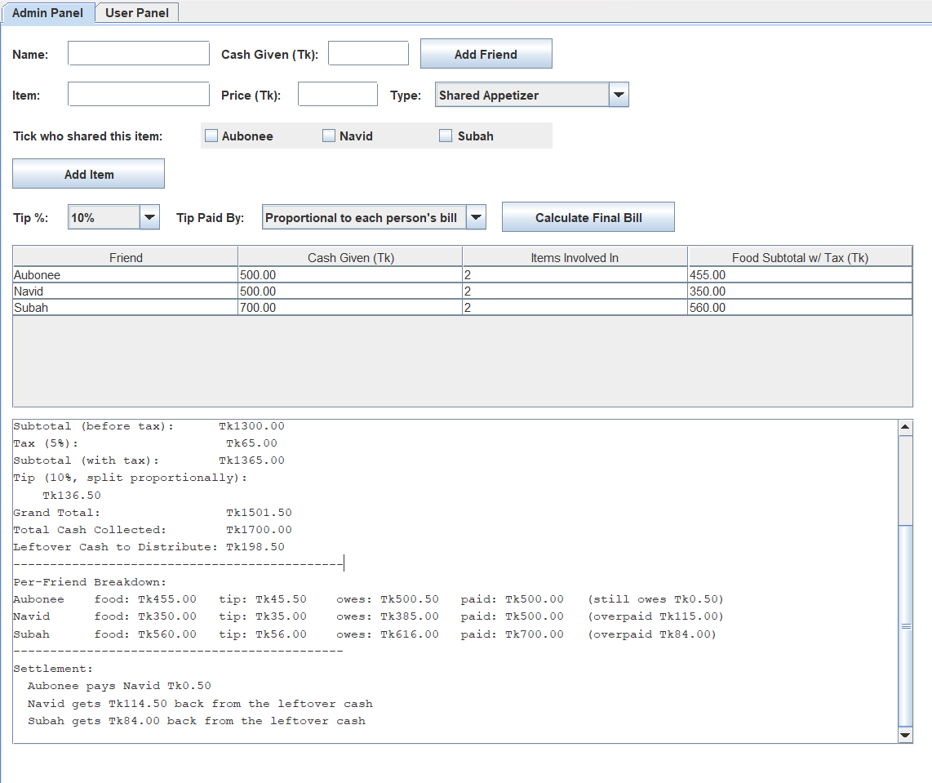

11. Appendix B – UML Diagram

